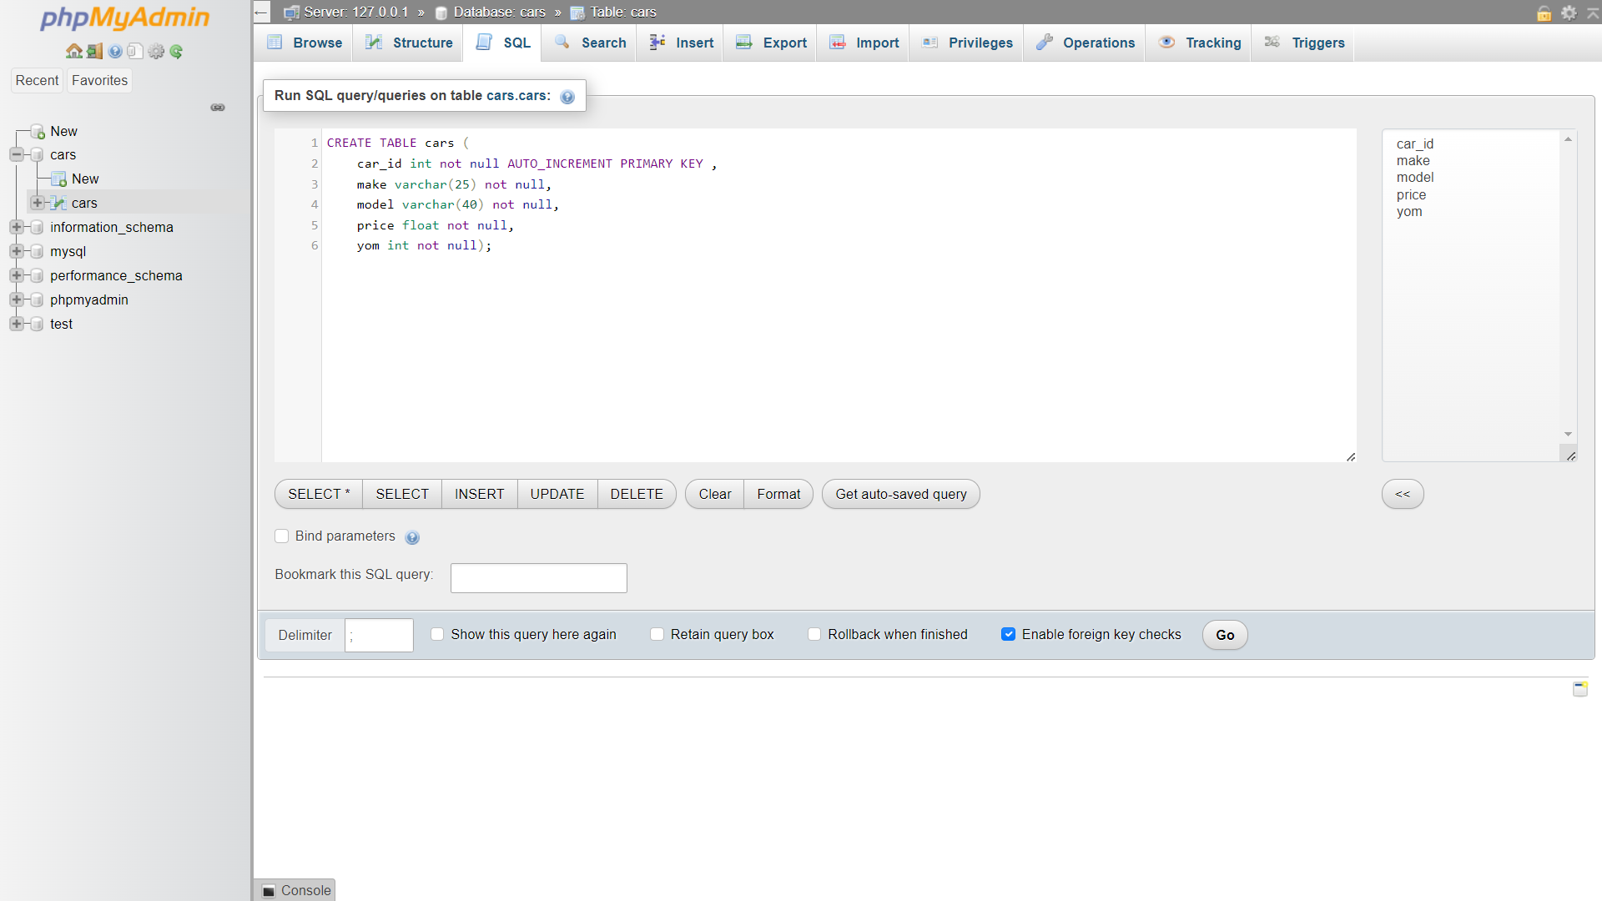

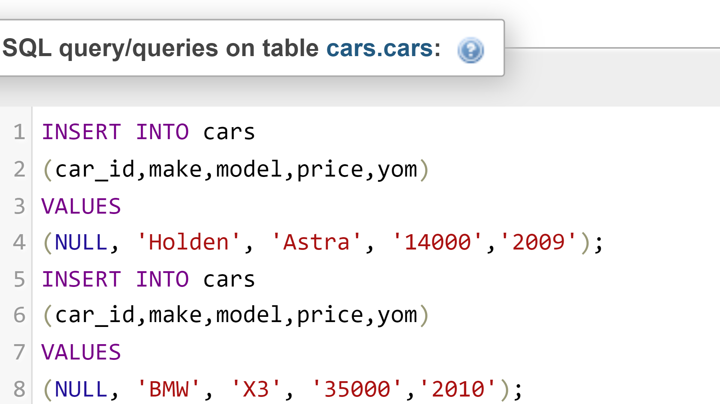

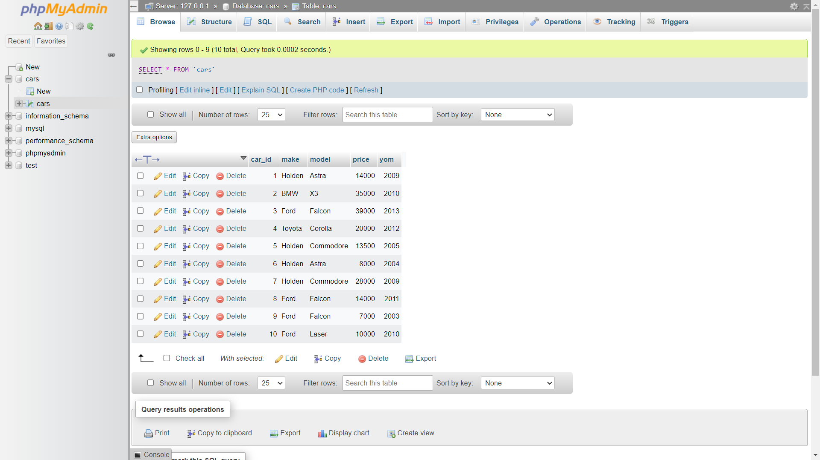

5.

SELECT make,model FROM cars

WHERE price <= 15000;

6.

SELECT AVG(price) from cars

WHERE make = "Ford”;

7.

SELECT price,yom FROM cars

WHERE price <= 15000 AND yom >= 2010;